**Project Title:**

Mobile Search Engine.

**Application Name:**

Click Mobile.

**Project Description:**

This project is about a mobile search engine that offers different features. It will give the user information about new mobiles and also the information about specifications of any mobile, price of the mobile, and you will also be able to test some of the mobile functionalities virtually such as massaging and calling.

**Manual Problem:**

This app offers information about mobile specifications. Manually if a person needs to know about a mobile he will go from shop to shop to know about the mobile this can cause in the wastage of time or compare two mobiles side by side sometimes some of the shopkeepers do not know the full specification of the mobile and this can cause lack of knowledge on the information of the mobile. This application resolves the following problems:

* Time will not be wasted.
* You will find everything at one place
* Full information about the specifications of the mobile.

**Project Feature:**

These are the feature of this mobile search engine:

* It will give information about new phones.
* It will give detailed specifications of the mobile phones (Memory, Display, Camera, etc. )
* The user can find the mobile from the Category option that is based on the specific specifications ( brand, operating system, ram, price, etc.) of the mobile. If the user could not find the mobile there he can also search for the specific mobile.
* The user can also compare the specification and prices of the two mobiles.
* The user can test some of the mobile functionalities virtually such as massaging or calling.

**Scope:**

This application is a console base that will run on PC and desktop computers.

**Tools:**

* **Language:** The language that I have worked on is C++
* **Method:** The method that I have used were the fundamentals of C++ and the concepts of OOP that are used in C++

**UML Diagram:**

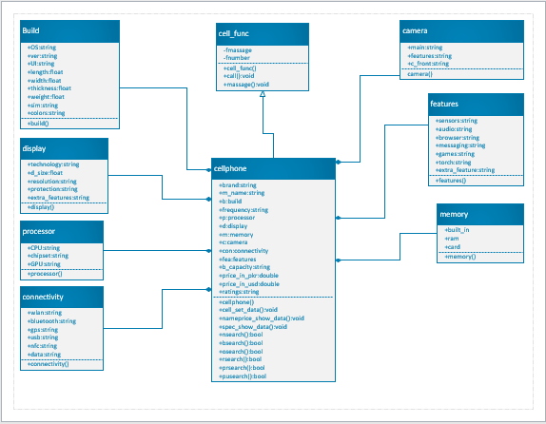

**Conclusion:**

Your time will not be wasted visiting different shops to decide which mobile phone you want to buy you will be able to see all the mobile details and prices at one place and as a result your time will be saved.